EC2 day 2.md 3/14/2021

Table of contents

Table of contents

EC2 day 2 :

Elastic ip

Creating EIP

ENI

Creating an ENI

EBS volume

Snapshot And AMIs

Creating snapshot

Creating an AMI

Lifecycle manager

Creating lifecycle policy

FAQ

EC2 day 2 :

We have see in our last session that we can coonfigure and create an ec2 machine in aws and use it for various pruposes for ex. installing a web server
Today we have to focus on smaller components of ec2 as a service and how to utulize them

Elastic ip

Elastic ips are static public ips that persist independent of the ec2 machine

If there is a use case where external traffic is reffaring to the public ip of our instance then we can utlize elastic ip
Usually the public ip that is given to use by aws by default is taken away when instance is stopped and is replaced when we start it again with a different ip address With elastic ip we can make sure that it stays constant
Elastic ips are not billed seperately if they are attached to a running instance . However when we stop the instance or if the EIP is sitting idle , we have to pay for the same .

Creating EIP

In order to create an EIP , navigate to the ec2 dashboard and click on elastic Ips
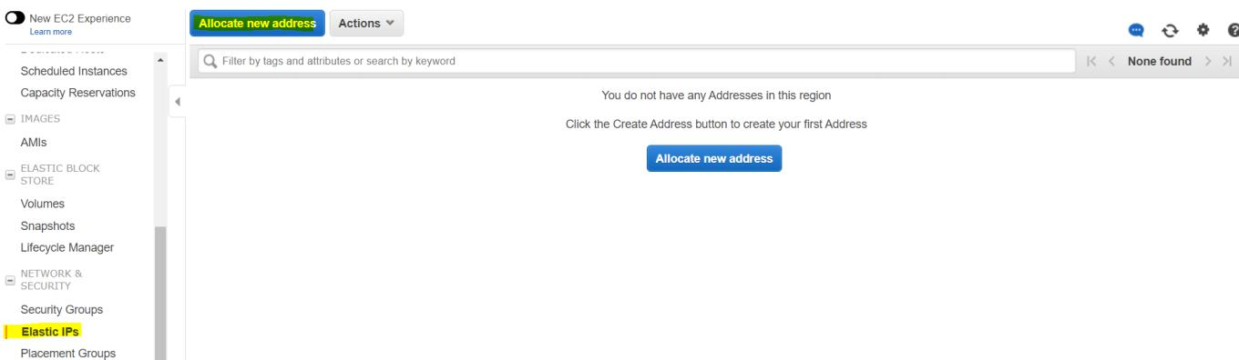

1 / 7

EC2 day 2.md 3/14/2021

Once we click on allocate new address , we simply need to click on allocate to get an EIP
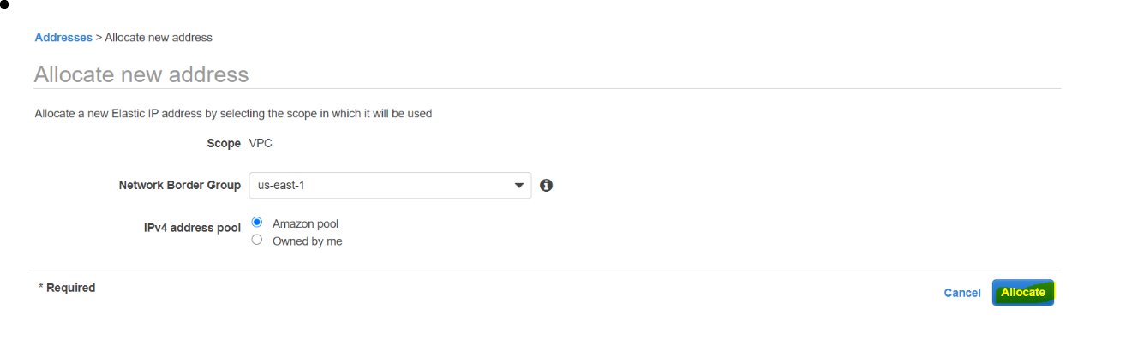

Once the EIP is created , it can be associated with an instance by going to actions and clicking on associate

Remember , in order to delete an EIP , we first need to Disassociate the EIP from an instance and then click on release address to give it back to aws . Post which our billing would be stopped

ENI

ENIs are similar to our EIPs but they carry extra importance from the networking perspective Just like EIPs are static public ip addresses, ENIs are static private ip address
Whenever an instance is created , it creates a eni in the background which late gets released after instance termination
We can also create our own eni to keep our private ip address static

ENI is responsible for network level properties like security group , subnet , private ip etc.

Once EC2 can have 2 enis . Once an eni is attached to the ec2 , it will carry over all the network related settings assigned to that eni

Creating an ENI

Navigate to ec2 dashboard and go to Network interfaces Click on create Network interface
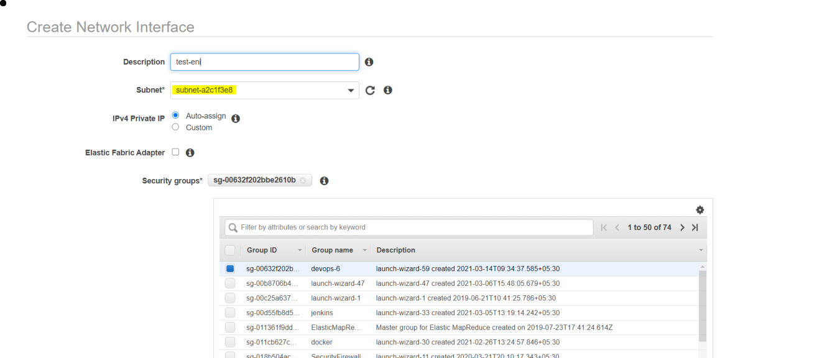

Select the subnet (this should be the same as the one you'd want your instances to be in )

Select appropriate security group and click create

Once created it can be attached and detached to instances

2 / 7

EC2 day 2.md 3/14/2021

An ENI can be attached to only one ec2 instance at a time

EBS volume

EBS volumes are storage for your EC2 machines . Imagine them to be similar to your hard discs EBS volume come with multiple types to support various use cases in terms for performance requirement (magnetic ,ssd, provisioned IOPS etc )
EBS volumes can be created during the launch of the ec2 or seperately .

A volume can be modified when it comes to scaling up the storage . We cannot decrease the capacity of the volume once it is created . We can only increase it
One ec2 instance can have multiple EBS volumes attached to it , however one ebs volume can only be attached to one instance at a time .
EBS volume can also be detached and attached similar to EIP EBS volumes persist independent of EC2 instances
These are high performance block storage devices which are designed to compliment high end workloads
In order to scale the storage of the ec2 , there are 2 ways it could be acheived

Modify the current EBS volume

Navigate to Volume , select your volume and click on actions

Edit the capacity with new value and click on modify . It will take some time to reflect

Create a new volume and attach to the instace

Navigate to Volume , click on Create volume
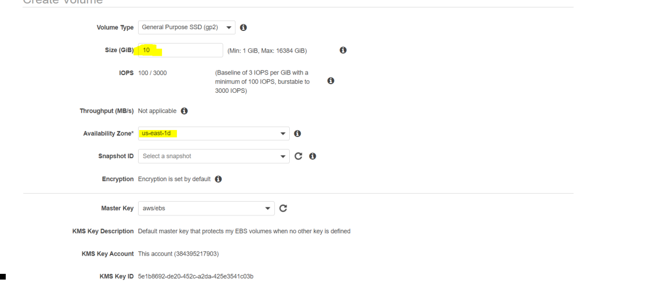

Remember to select the AZ in which your instance is running . EBS volume cannot be atatched to instance running in other az
Select the desired capacity and create the volume

Once volume is created , you can go to actions and attach it to the desired instance There other steps we have to perform from linux end for storage scaling which we will see later

Snapshot And AMIs

Since EC2 is IAAS , we have to configure the backups ourselves

AWS gives us few options to carry out the backup activity in a flawless manner Snapshots are clold backup of your EBS volume or EC2 instance .
In the background these are stored in S3 (We dont see them in S3 . This is just for our understanding )

3 / 7

EC2 day 2.md 3/14/2021

These are point in time backups which means they only store data till the time when the backup was initiated .
Once the backup is taken and then if there are any changes then the snapshot doesnt record it

Creating snapshot

Navigate to snapshot screen from ec2 dashboard and click on create snapshot
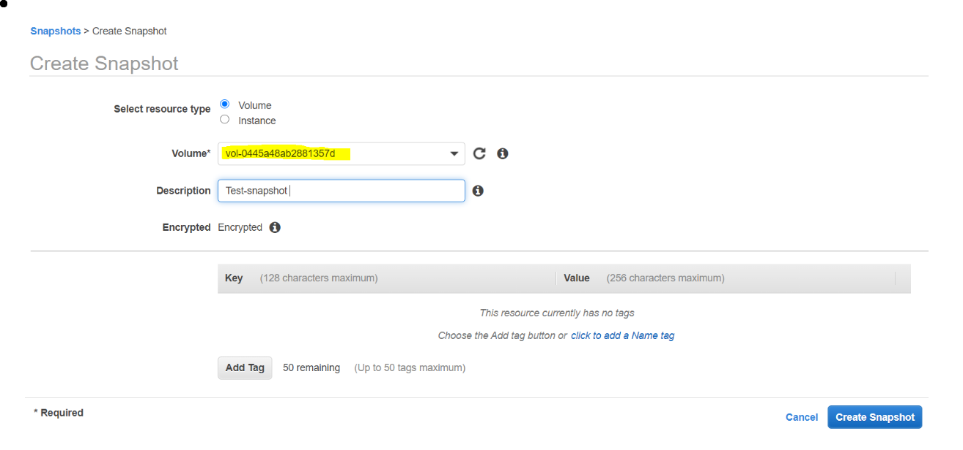

Select appropriate volume and click on create snapshot

It will take some to become available . Once it does , it can be used to create volume or AMI

Since snapshots cannot be directly attached to a instance , you either need to create a volume or image out of it in order to use it

Also snapshot approach can become tedious if there are multiple ebs volumes attached to an instance . This limitation is the reason companies stick with AMI
AMI is a image of your machine . It contains OS as well as additional packages .

We have seen default AMIs till now for ex . amazon linux , ubuntu etc

We can create our own AMI which can either be used as a backup or can be used as template to avoid reinstallation of service or packages.

AMIs also use snapshots in the background . These are just a wrapper over the snpashots

Since we take AMI of the instane , it records every volume that is attached to the machine and gives us the complete bundle so we do not have to create seperate snapshots .

These are the most common method to take backup of the EC2 machines

Creating an AMI

Select your instance and click on actions

4 / 7

EC2 day 2.md 3/14/2021
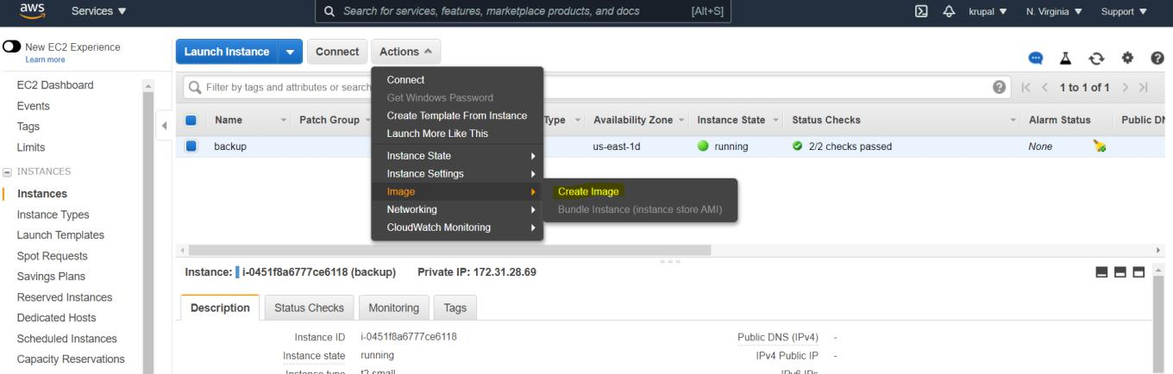

Select Image and click on create image
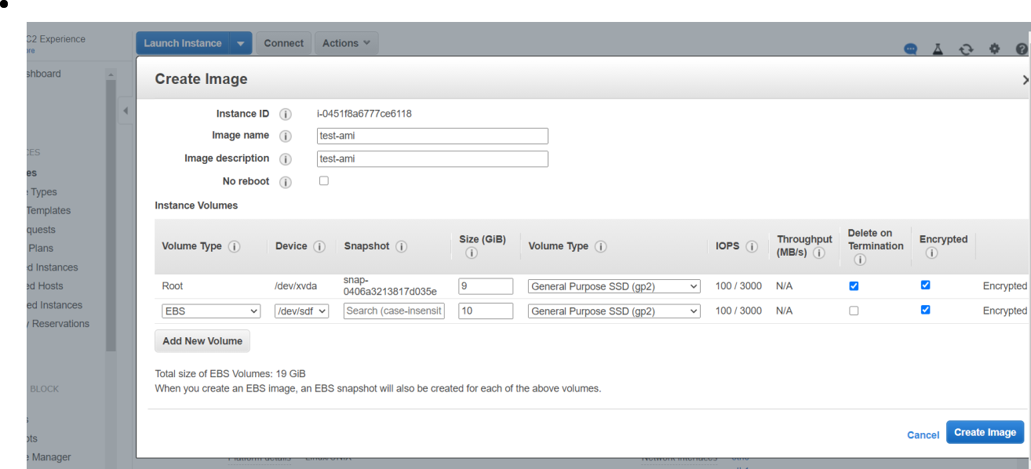

Give appropriate name for the ami and click on create image . It will take some time to reflect and you will be able to see it under AMIs tab in EC2

You can use the same AMI to launch EC2 machine. It will contain the same data as the instance which was used to create this AMI

Lifecycle manager

Since backups are a part of the compliance for organizations , we need to have some automation to avoid manual intervention
Lifecycle manager lets us schedule backups for our machines

This feature also helps us retain only specific amount of backups to avoid unnecessary cost

Creating lifecycle policy

5 / 7

EC2 day 2.md 3/14/2021

Navigate to EC2 and click on create lifecycle policy
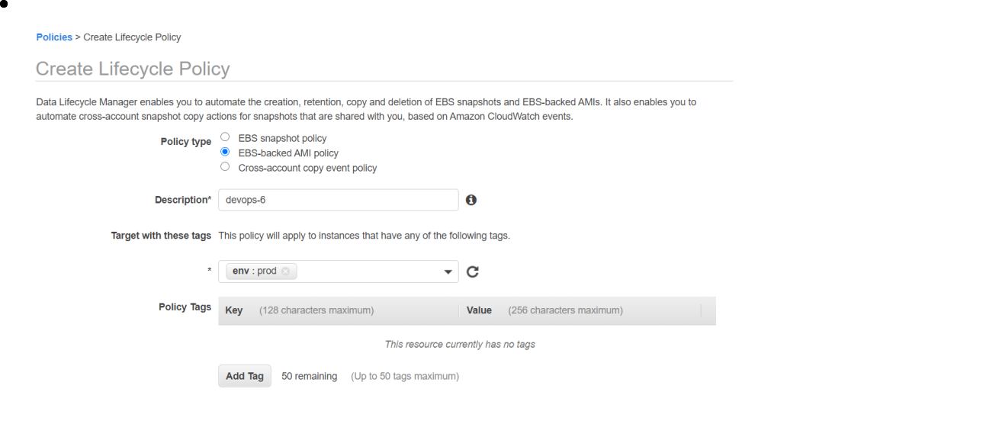

Select the policy type as EBS-backed AMI polic

Give appropriate description

Target with tags option gives us option to specify the tag . Every ec2 which has that specific tag key and value , those will be backed up under this policy
For the schedule , we can define the frequency at which we want our backups to be taken
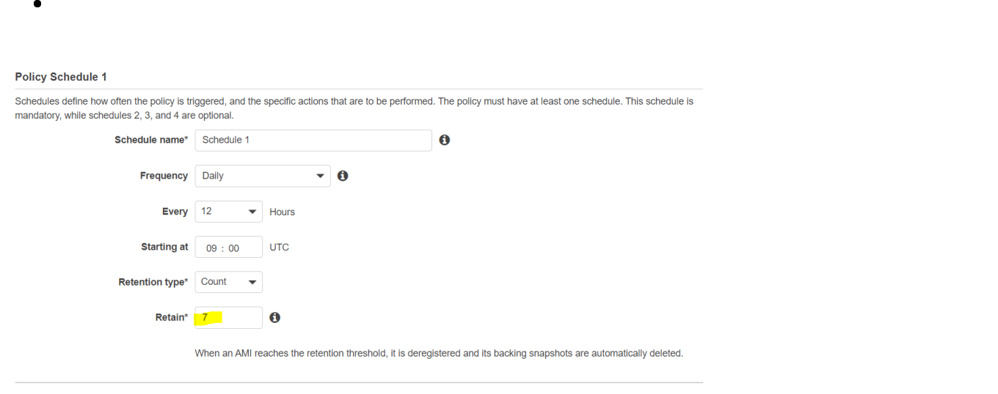

Also we can mention the retention . Here we have mentioned 7 . Which means it will maintain straight 7 backups , for the 8th occasion it will delete the oldest backup . So at any point in time , we will have 7 backups .

These backups are increamental , which basically means for the first backup it will be taken from scratch

- From there onwards for next backups , it will just observe the changes that were done since last backup , it will only record those and create a new backup . This takes significanlty lesser amount of time

FAQ

Whats the use case for EIP and ENI

EIP and ENI can be used to keep the ip addresses constant . So that in case of disaster , we shoudnt have to change any code or inform the users

6 / 7

EC2 day 2.md 3/14/2021

Are there other methods for backup

Customized scripts can be created . Also aws has introduced aws backups service for the same

How to scale comupting power of EC2 machine

We have to change the instance type to scale the computation power . For this we need to stop the instance and change the instance type from instance settings

7 / 7

